Value
Value is the relative lightness and darkness of a color or grey tone. Color, as well as black and white, has value. When you turn a color photo into a black and white version you can see the relative values of the colors. A successful image is equally strong in black and white as it is in color. A good way to check your values in a color artwork or photograph is to open the image up in Photo shop and desaturate the image until no color is left. Is the image washed out and grey? Then it's color values aren't intense enough and the image will look better if you adjust the contrast.
You can't have any image without value, so it is very important for the artist to always be aware of the various values in his artwork and how they affect the composition. Drawings with low contrast in values, where most of the tones are washed out or grey, will look dull and subdued. The best artwork will have a full ranges of values, from the darkest darks to the lightest lights. Any artwork will "pop" and will be improved if the values cover the full range. The single most effective thing an artist can do to raise the quality of his art to a professional level is to develop a good eye for value.
In value, it is the contrast of dark and light values that are important. If most of the painting is light, then the dark lines and shapes will catch the eye first. If the predominant value is dark, the light value will catch the eye first. As a general rule, light tones and white catch the eye first, but in the end, it's contrast that's most important. Use contrasting value as a way to bring the viewers eye to your focal point and as a means of managing your composition.
A photograph or artwork should have a full range of darks and lights, however, don't make the mistake of letting your dark or light areas be solid, muddy or dead. Look at the dark areas under the boats, below. Photograph 1 has the full range of values, photograph 2 has lost the details in the dark areas. Photograph 3 is washed out and has an overall grey tone because the darks are too light and the lights are too dark.

Value Considerations
From "Design Basics for Creative Results by Bryan Peterson".
- Have you really chosen the values present in your design?
- Have you intentionally chosen values that provide contrast?
- Have you intentionally chosen values that are very similar to provide subtle, or blended effect?
- Does your value help move the eye through your design?
From Mrs. Taylor
- Does your focal point's value help it dominate the page?
- Do you have a full range of values, from the darkest darks to the lightest lights, in your design?
- Do your very dark areas have subtle changes in value, or are they muddy and solid?
- Are your lightest areas bright or washed out?
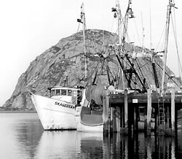
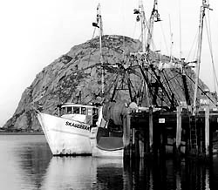

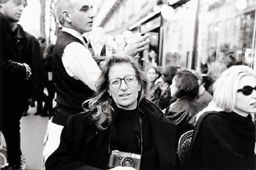
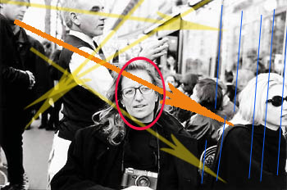
In the photo of Annie Liebowitz above, look at how the values create a strong diagonal (orange arrow) and affects the balance of the composition. Even though the focal point (red circle) is in the center, the strong darks contrasted with the light triangle on top offset the balance and keep the composition from becoming static. Notice also how the verticals (yellow arrows) bring the eye back to the focal point and the subtle verticals keep the eye from leaving the page. What do you think would happen to the composition if the white area in the lower left were filled in with black? If the woman on the right in sunglasses was not there?


