Unity and Variety
An artwork has unity by the way the bits and pieces in a work of art hangs and goes together..or "the whole is greater than the sum of it's parts". The difference between a professional look and an amateurish piece is often the artistic choices you've made about values and unity.
Unity can be created with an overall texture, pattern, repeated theme (rhythm), and limiting the number of colors in a piece. You can unify a project that crosses a number of pages with all of the previous methods as well as using a placement grid. This website uses a grid that places each element (titles, body copy, links bar, pictures) in a certain place. This makes all the pages look like they are part of a consistently designed site and that creates unity. An individual artwork can use a grid if there are a lot of elements, but the grid system is usually used to make a project that involves a lot of different pages or media look like they are all related.
Variety is the use of different elements in the artwork. Variety creates excitement. Art that has too much variety is "busy" and confused. Too much unity is boring. The artist's job is to find that perfect balance between the two.

Unity Considerations
From "Design Basics for Creative Results by Bryan Peterson".
- Does the design you want call for a grid?
- How complex does your grid need to be?
- What elements will be consistently placed according to the grid lines?
- Where might it benefit your design to break the grid?
- When you look at the pages where you've broken the grid, do they seem to connect with the pages where your grid is intact?
- Have you been able to achieve unity through the use of similiar elements?
- Have you eliminated elements that distract the eye and pull it away from important parts of your design?
Below are some examples of artwork that show unity. I've typed below each piece some of the elements that the artist has used to create that unity. What do you think the artist has done that makes each piece a whole, complete, satisfying work of art?
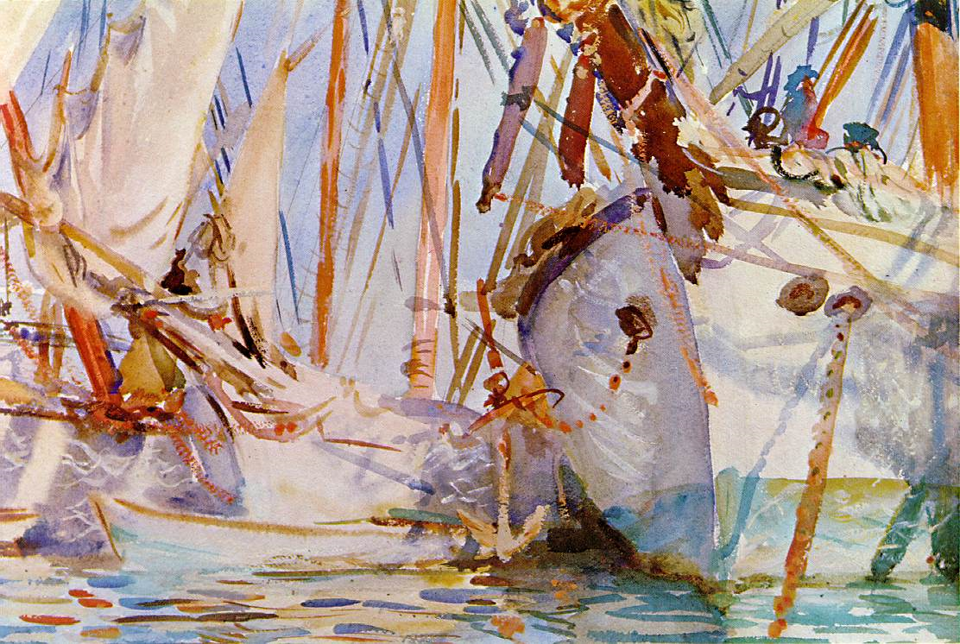
Unity is established with limited color palette, repeating shapes (masts and rigging), and repeated brush stroke patterns. Notice how the brush strokes that make up the water are the same weight and thickness of the masts.
Jasper Johns has arranged his color in triads across the page. Notice how the red makes a triangle across the page, as well as the purples and the yellows. All of the colors have the same level of saturation (intensity) that is subdued and greyed. The thickness of the blue/grey lines that go across the artwork is about the same, but instead of being boring, they wiggle and dance and lead the eye around (rhthym). He uses textures almost arbitrarily across the page, but keeps it them from being boring by using a variety of lines and type and drips. Notice that the wood texture is the exact same color as the outline around the man, another way of bringing together two different patterns.
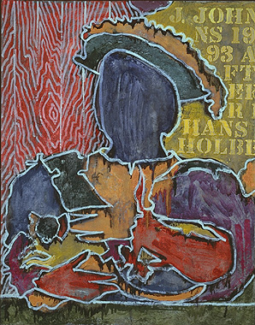
Again, the color palette is limited. Rene Magritte used greyed tones and pastels throughout the work. The windows, which repeat across the bottom of the piece, and the men are about the same size, which, along with the repeated men, create a pattern across the entire painting. Relief from the constant pattern is provided by the plain grey building on the right. Since the artwork is busy with pattern, the plain grey side of the building is where he put in some variety.
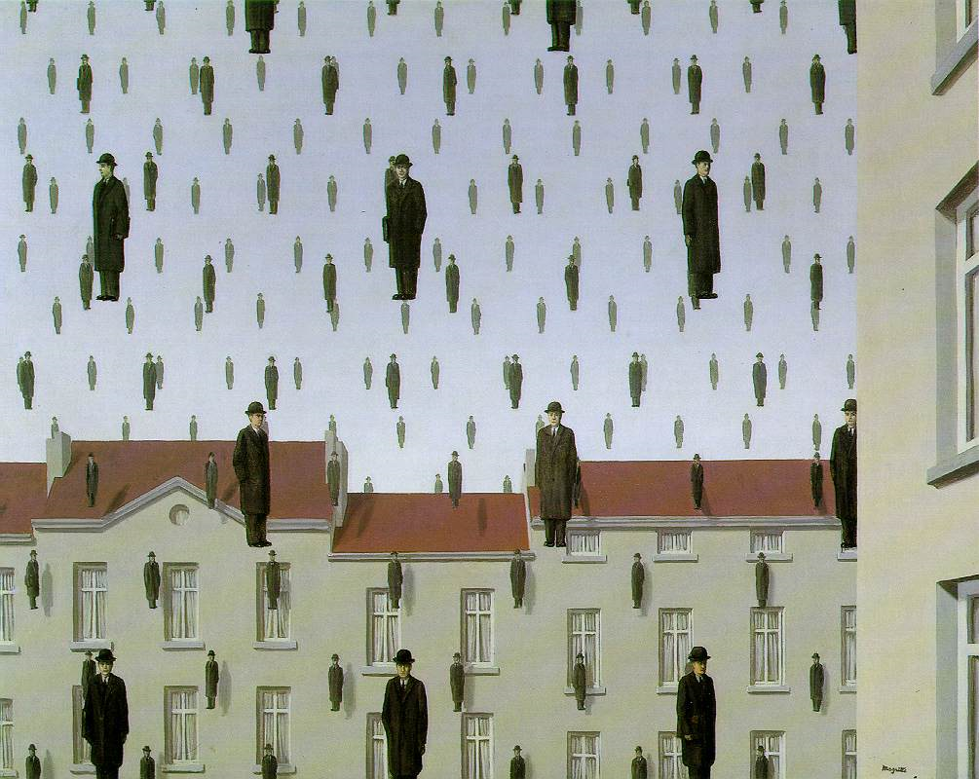
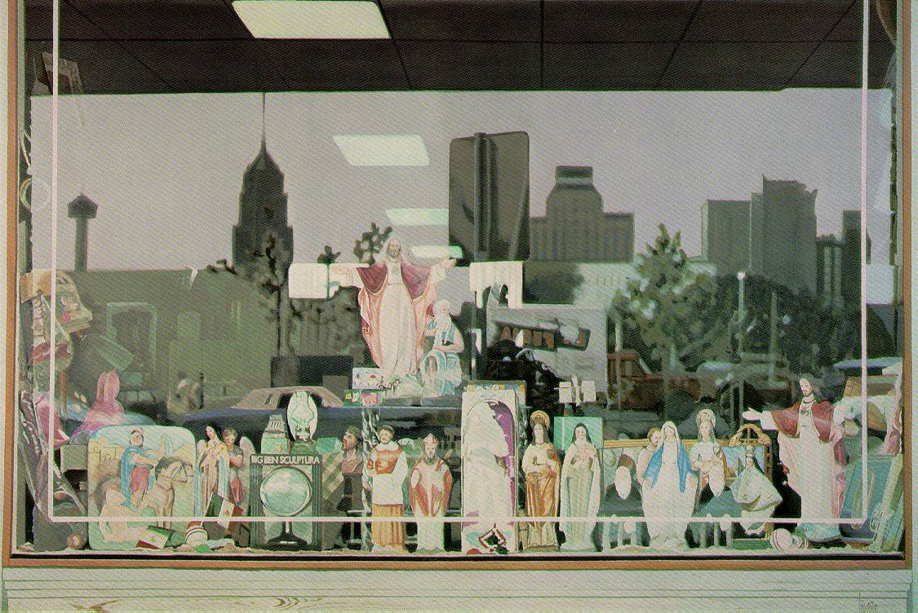
Santos creates unity by using a limited color palette and a smooth texture across the canvas. While it's obvious that the buildings in the back of the reflection repeat themselves, and the religous icons in the bottom of the reflection repeat as well, notice that the Mary's and Jesus' in boxes repeat the shapes of the buildings above them, and that the box motif is repeated in the ceiling lights and tiles. The figures, also, make a jagged, skyline-type edge that is repeated by the reflected skyline.
Seurat uses the textures of his brushstrokes (the dots across the canvas) as well as a limited color palette to create unity. Notice that the ship's masts and smoke stacks repeat across the canvas and the line/mast motif is repeated in the flags and railways, and even repeated in the narrow slice of building on the far right, which is also the same thickness as the masts on the left.
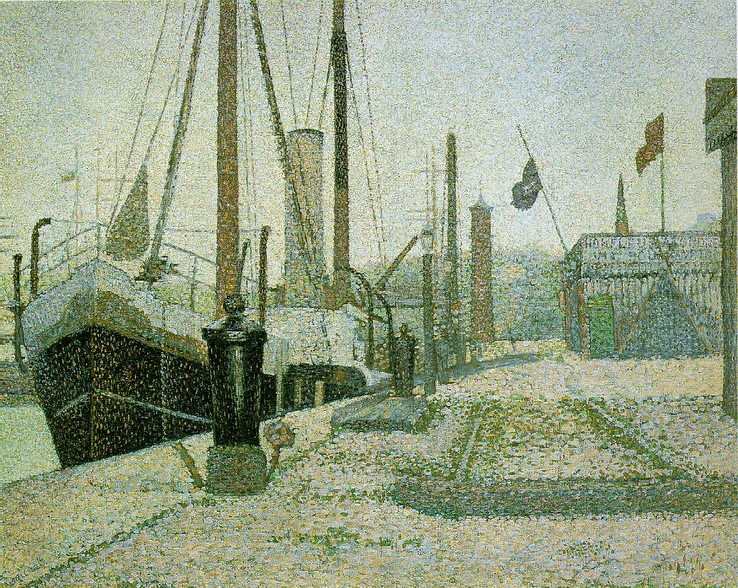
At first glance it might be obvious that the easiest way to create unity is to repeat one item over and over. Thiebaud does that here, but he also uses other methods. His palette is limited in color and value. He also scatters the bolder colors and values in triads across the canvas. Notice how he has the brown and yellow cakes arranged to form triangles across the picture plane. Variety is created by using the sliced cake with the sharp horizontal layers in the upper right. Imagine if that cake were round like the others, or just one or two layers. The picture would become too repetitive if he had made that decision. Where do you think the focal point is of the composition? Why?
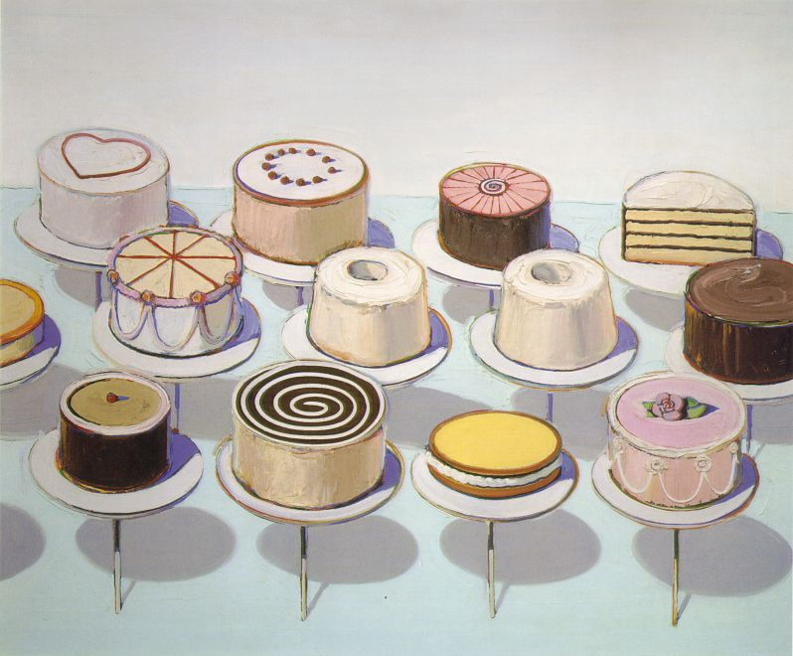
If you look at the large view of Wyeth's painting you'll notice that the entire surface is covered with a rough, scratched texture, even the areas that should be read as smooth, like the teapot. Notice how the cracks in the teapot are repeated in the shelf, and very lightly, in the background. Wyeth also subtly repeats the lines of the horizontal shelf as verticals in the background. And, as the other artists did, Wyeth was disciplined in his use of a limited palette of creams, browns and tans.


