Illusion of Space
Using 1, 2, 3 point, and aerial perspective, the illusion of space can be created in a work of art. Always think of a foreground, middle ground and background in your art.
Overlapping will also create an illusion of depth.
There is a tendency for unsophisticated artists to work in a very shallow depth of field. They have their elements arranged on like a police line-up, with the parts of the composition placed in a very narrow area. Yes, there are great works of art with a very shallow depth of field, but remember, the difference between them and the beginning artist is that they are choosing to use a shallow depth of field for a purpose, which is to emphasize a mood or feeling, not by accident.
Shallow depth creates a feeling of intimacy, claustrophobia, "indoors", and causes the view to focus on the parts of the artwork that are immediately in their field of vision. Shallow depth makes the viewer feel large in relation to the artwork.
A wide or deep depth of field creates a feeling of "outdoors", expansiveness, and openness. A wide depth makes the viewer feel small in relation to the artwork. Can you name a type of artwork where you would want the viewer to feel small and insignificant? Can you think of an instance where you would want the viewer to think he is large and important?
Space can be created with aerial or atmospheric perspective, which is the use of relative size, color, value and clarity (sharpness of the image area) to create the illusion of depth. Bright, hot and saturated colors and light values spring forward; dull, cool and desaturated colors recede. The further something is back in the distance, the smaller, bluer, duller and fuzzier the object is.
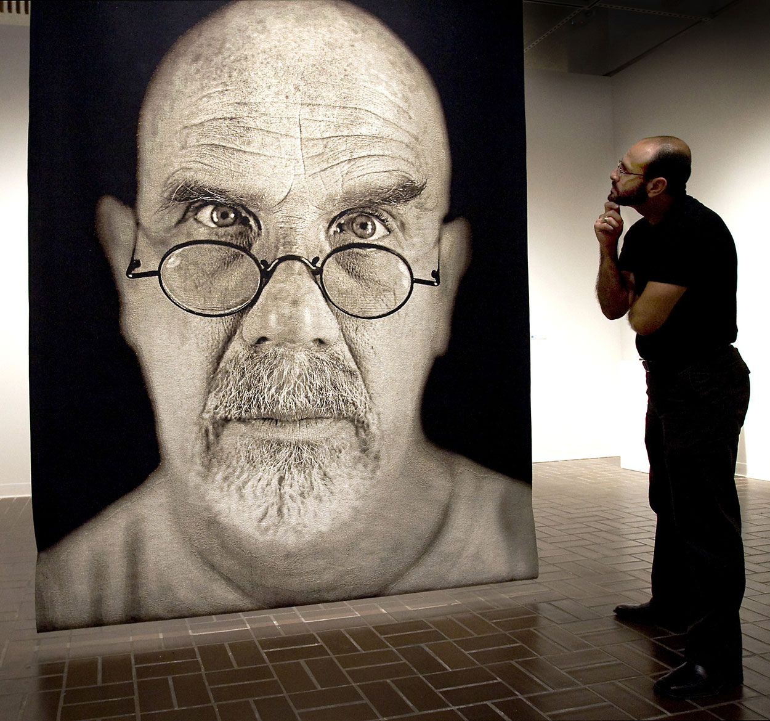
Whatever space choices you make, layer your elements and force the viewer to look around the painting. By layering and hiding parts of things, you make the view study the artwork and give him a reason to keep looking at it.
Chuck Close's early work had a very shallow depth of field and no overlapping. His canvases are very large and the oversized proportions of his subject matter forces the viewer to confront the art immediately and personally. His art leaves the view feeling small and while the expressions on the face of the people are neutral the overall feeling is aggressive and intimidating.

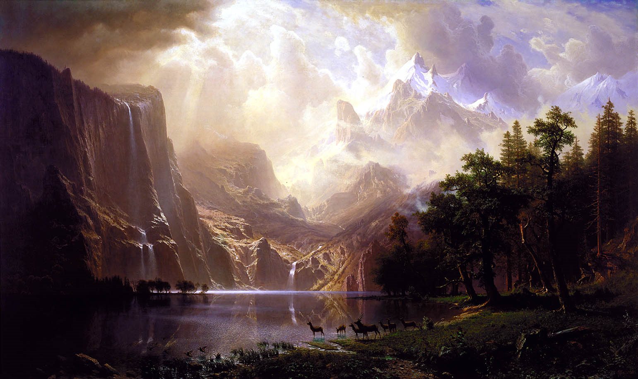
Albert Bierstadt was overcome by the magnificent scenery of the unspoiled American landscape. His paintings are very large and in a gallery they fill the room, but by having a very deep depth of field and an abundance of overlapping the viewer feels almost god-like in his command of the terrain. While dramatically painted, the viewer sees and controls the experience and looks at the details at his leisure and so the viewing experience is a metaphor of the "divine right" of the American explorer to conquer and command the vast frontier.



