Color
Color is the wavelength of light that is reflected back to your eye. Everyone's brain processes color differently and what you see is slightly different from what I see. Usually this is not an issue, but some people will see color quite differently or not at all. Color blindness is quite common. When you design for websites, computer games, animation and media that is meant to be utilized, make sure you don't use color combinations that will be a problem for large groups of your target market.
Color will override placement in the composition and attract your eye first for those with good color perception. For those without good color perception,value and texture will override color.
Bright, saturated colors will jump forward and catch the eye first. Pale, dull colors will recede.
Color is highly emotional. Saturated colors, "hot" colors will catch your eye first and imply excitment, heat, movement, rage, happiness (intense feelings). "Cool", desaturated colors recede and imply calmness, coolness, stillness, neutral, calm feelings. Colors are associated with certain cultural ideas (blue for boys, green for environmental awareness, red for danger, etc.) .
All colors have a warm or cool component. You can have a cool red and a warm blue. By keeping your colors in the same temperature you can contribute to the unity of the artwork. Often when you work with colors that seem to not "go together", it's because they're not of the same color temperature. Even neutrals, such as white, black and grey can be warm or cool.
Use complementary (opposites on the color wheel) color to add excitement and pizazz to any artwork. Complementary colors next to each other will "jitter" and vibrate. Use color to unify the art by inserting and scattering bits of the focal point's color around the artwork.

Color Considerations
From Design Basics for Creative Results by Bryan Peterson.
- Do you have a full range of values in your work, or is color being used to "save" a poorly conceptualized design?
- Would a predominantly cool color scheme be enlivened with warm accents (or vice versa)?
- Have you considered the appropriate use of neutral colors in your design?
- Would your design work better with the full brightness of color (saturation), with grayed tones or with pastel tones?
- Would your design be more visually pleasing by using color sparingly as sharp accents?
- Do you have a design that would actually work best in black and white?

Here are some samples of artwork that emphasize color. Next to some are samples in black and white. Look at how the artist's work translates well into black and white because he was conscious of values as well as color. Notice also how the artists scattered color around the picture plane to unify the art AND how complementary colors are placed next to each other so that they "pop".

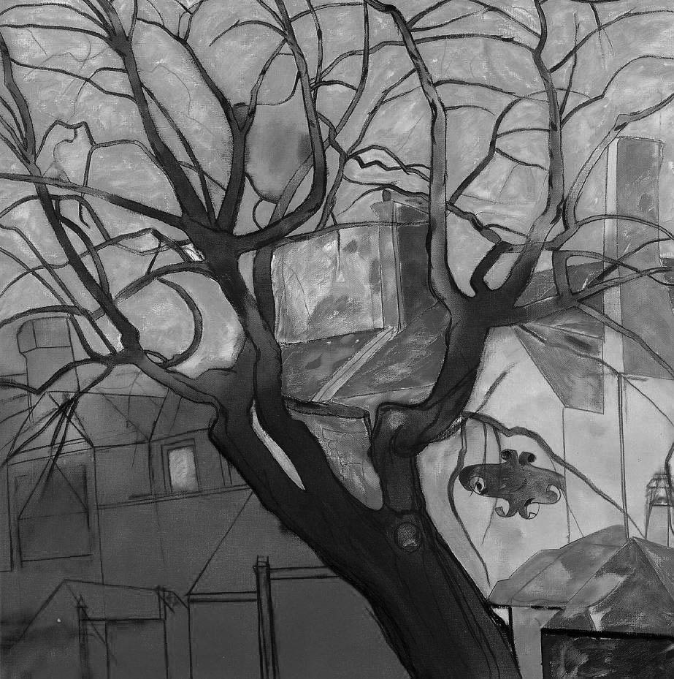
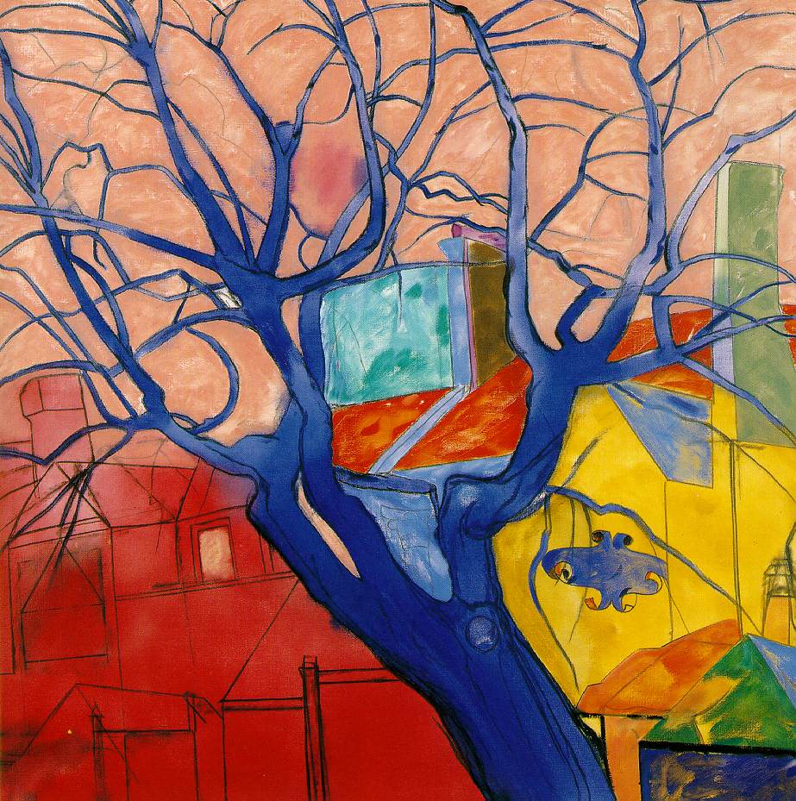
Color Theory Vocabulary
Color | Element of art that has three properties: hue, value and intensity. Color is a property of light. (Issac Newton)
Hue | Pure color
Intensity | Brightness or dullness of a color
Primary Color | Red, Yellow and Blue, cannot be created by mixing any other colors.
Secondary Color | Colors created by mixing two primary colors ( Green, Violet, Orange)
Tertiary (Intermediate) Colors | Colors created by mixing a primary and a secondary color.
Complimentary Colors | Opposite each other on the color wheel (red & green)
Analogous Colors | Colors that are directly next to each other on the color wheel  Ex: Red-Violet, Red, Red-Orange
Cool Colors | Blue, Violet, Green
Warm Colors | Red, Yellow, Orange
Monochromatic Colors | One color multiple tints tones and shades
Tint | add white to a color
Tone | add different shades of grey to a color ~ creates different intensities.
Shade | add black to color
Intensity | the brightness or dullness of a color  to dull out a color—add the compliment  To intensify a color add white or yellow.
Quadratic Colors | Colors that form a rectangle on the color wheel
Triadic Colors | Colors that form a triangle on the color wheel.

